**WORK INSTRUCTIONS FOR DRAWING A BELT CUT COKE SAMPLE FOR MOISTURE ANALYSIS**

**Responsibility:** Raw material in charge

**IDENTIFIED HAZARDS**:-

Mechanical Hazard-Fall of person, Entanglement, trapping impact

Chemical Hazard-Dust, fire and explosion, smoke

Physical Hazard: Electric shock, noise, Head lights of WL/Vehicle

**Human Behavior:**

1) Not following the Work Instructions, procedures

2) Non-use of PPE

3) Alcoholism resulting to health hazard and less response to hazards associated with the activity.

4) Wearing loose clothes

**Significant Aspects:**

1. Generation of dust

**PROCEDURE**

1. Unauthorized operation or repair of any equipment is a punishable offence.
2. Inform control room engineer before starting the activity.
3. Stop the coke belts (CB311/CB321), by operating pull chords provided along the belts, when the coke batching is ON.
4. Coke sample has to be drawn only when the pull chord emergency is activated, and the belt has stopped.
5. Open the cover of the belt canopy cutout provided and draw the coke sample of about one meter length with the help of a spoon, complete with all lumps and fines, and collect it in a container. The sample HAS to be drawn only from this opening.
6. Coke moisture sampling is done twice in a shift, so coke samples have to be drawn twice in a shift from CB311/CB321, by following points (1), (2) and (3).
7. Coke sample has to be drawn in the presence of the R/M engineer /company workman only.
8. After drawing the coke sample, it is the responsibility of R/M engineer/company workman to release the pull chord, which was activated to draw the sample, and inform the control room to reset the belt.
9. Ensure that the belt restarts, tag the sample appropriately and send it to the laboratory.

Detailed Procedure:

1. Instead of taking a half meter section of the loaded belt randomly; a prefabricated divider should be used as shown in the figure below. One sample of coke consists of uniform mixed composite sample collected after every three batch.

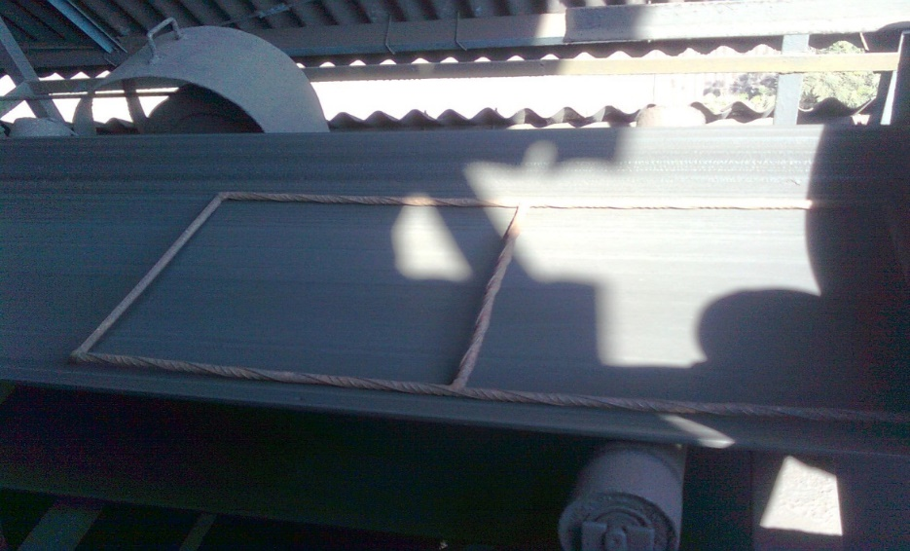

1. Proper gloves and brush should be used to collect the sample instead of handling with bare hand to ensure proper handling of course and fine particles.
2. Sample should be collected into a tin container instead of a gunny bag.

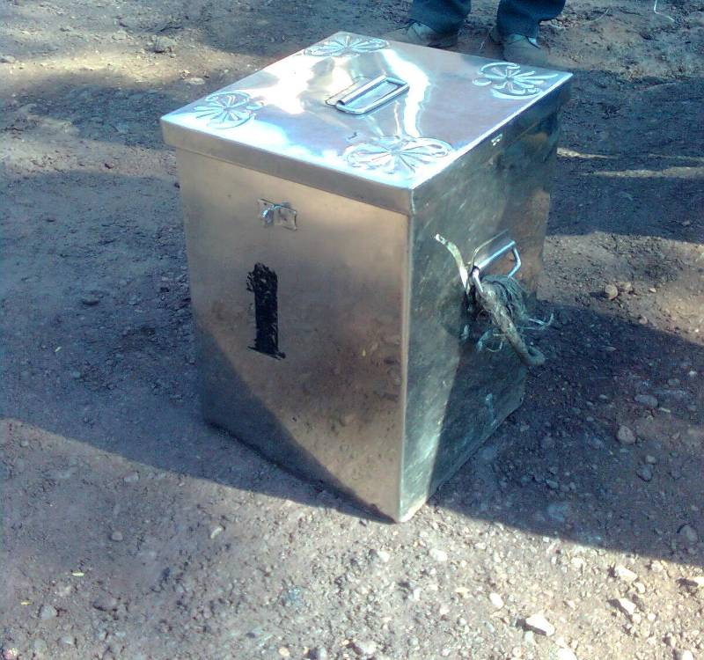

1. The proposed location for the collection of coke sample should be as shown in the figure below. It is near the coke weighting bin in BF#1 & for BF#2 at the existing location with some modification.

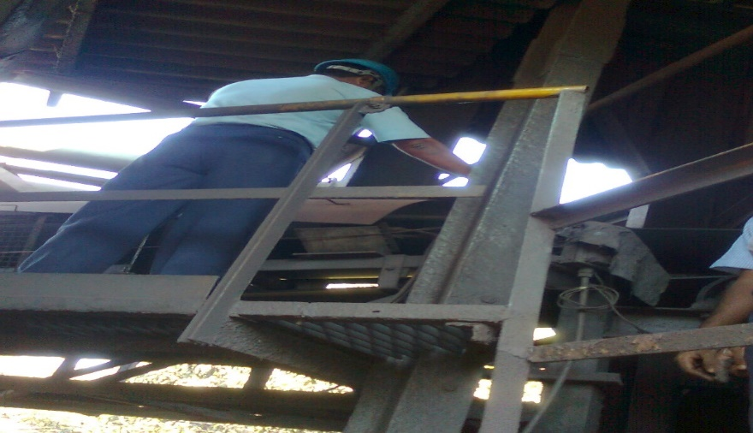

1. Instead of pull chord running alongside its length we propose for push button as in the Raw material area this will also take care of safety & save in timing for communicating with control room each time for reseating the belt.
2. 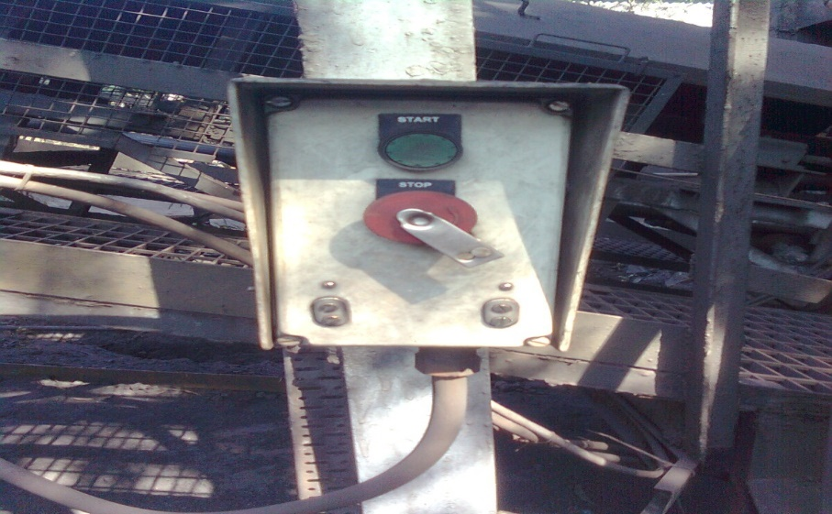
3. A tag, with all needed identification, must be placed inside the tin container to avoid any mix up
4. Together with the other samples, this sample must be sent to the lab for analyzing.
5. Acknowledge, in writing, the receipt of every sample at the lab.

|  |  |  |
| --- | --- | --- |
| **Prepared By:**  Head – Production PID | **Reviewed & Issued By:**  Management Representative | **Approved By:**  Head – Pig Iron Division |
| **Signature:** | **Signature:** | **Signature:** |
| **Date: 15.07.2022** | **Date: 15.07.2022** | **Date: 15.07.2022** |

|  |  |  |  |
| --- | --- | --- | --- |
| **Amendment Record** | | | |
| **Revision date** | **Manual Section ref. and para** | **Brief details of revision** | **New Revision No.** |
| 15.07.2022 | Procedure for drawing belt cut coke sample for moisture analysis | Point 2 | 03 |